ASSIGNMENT 1 ,WIND POWER



TSAVALOS Anastasios, MUÑOZ SÁEZ Javier, GAMEIRO Simon, BLANCHE Simon.



Contents

I - Downloading wind data of a specific location for the Global Wind Atlas 3

Choosing the location: 3

Choosing the Turbine (SG 8.0-167 DD): 5

II - Calculate the wind speed distribution: 6

Calculation of the Weibull parameters: c and k 6

Calculation of the Weibull distribution with our data: 6

III - Calculate the total energy production: 8

Power curve: 8

Capacity factor (CF): 9

Power coefficient (CP): 10

IV - Wind turbine cost analysis: 11

Wind turbine cost estimate: 11

Calculation of LCOE (without financing): 12

Calculation of LCOE (with financing): 13

V - Economic income calculation: 14

VI - Openwind validation 15

## I - Downloading wind data of a specific location for the Global Wind Atlas

### Choosing the location:

To choose the placement of our wind turbine, we scouted the [website](https://globalwindatlas.info/) GLOBAL WIND ATLAS.

We ended up choosing an **offshore** placement for our turbine, offshore was chosen due to the availability of bigger more interesting offshore turbine types.

The turbine is located in a common ground, equidistant from the countries of the team members France, Greece and Spain.

Our turbine is **located between Corsica and Sardinia**, right where the wind atlas map turns red, it seems like a very windy area and the food is great.

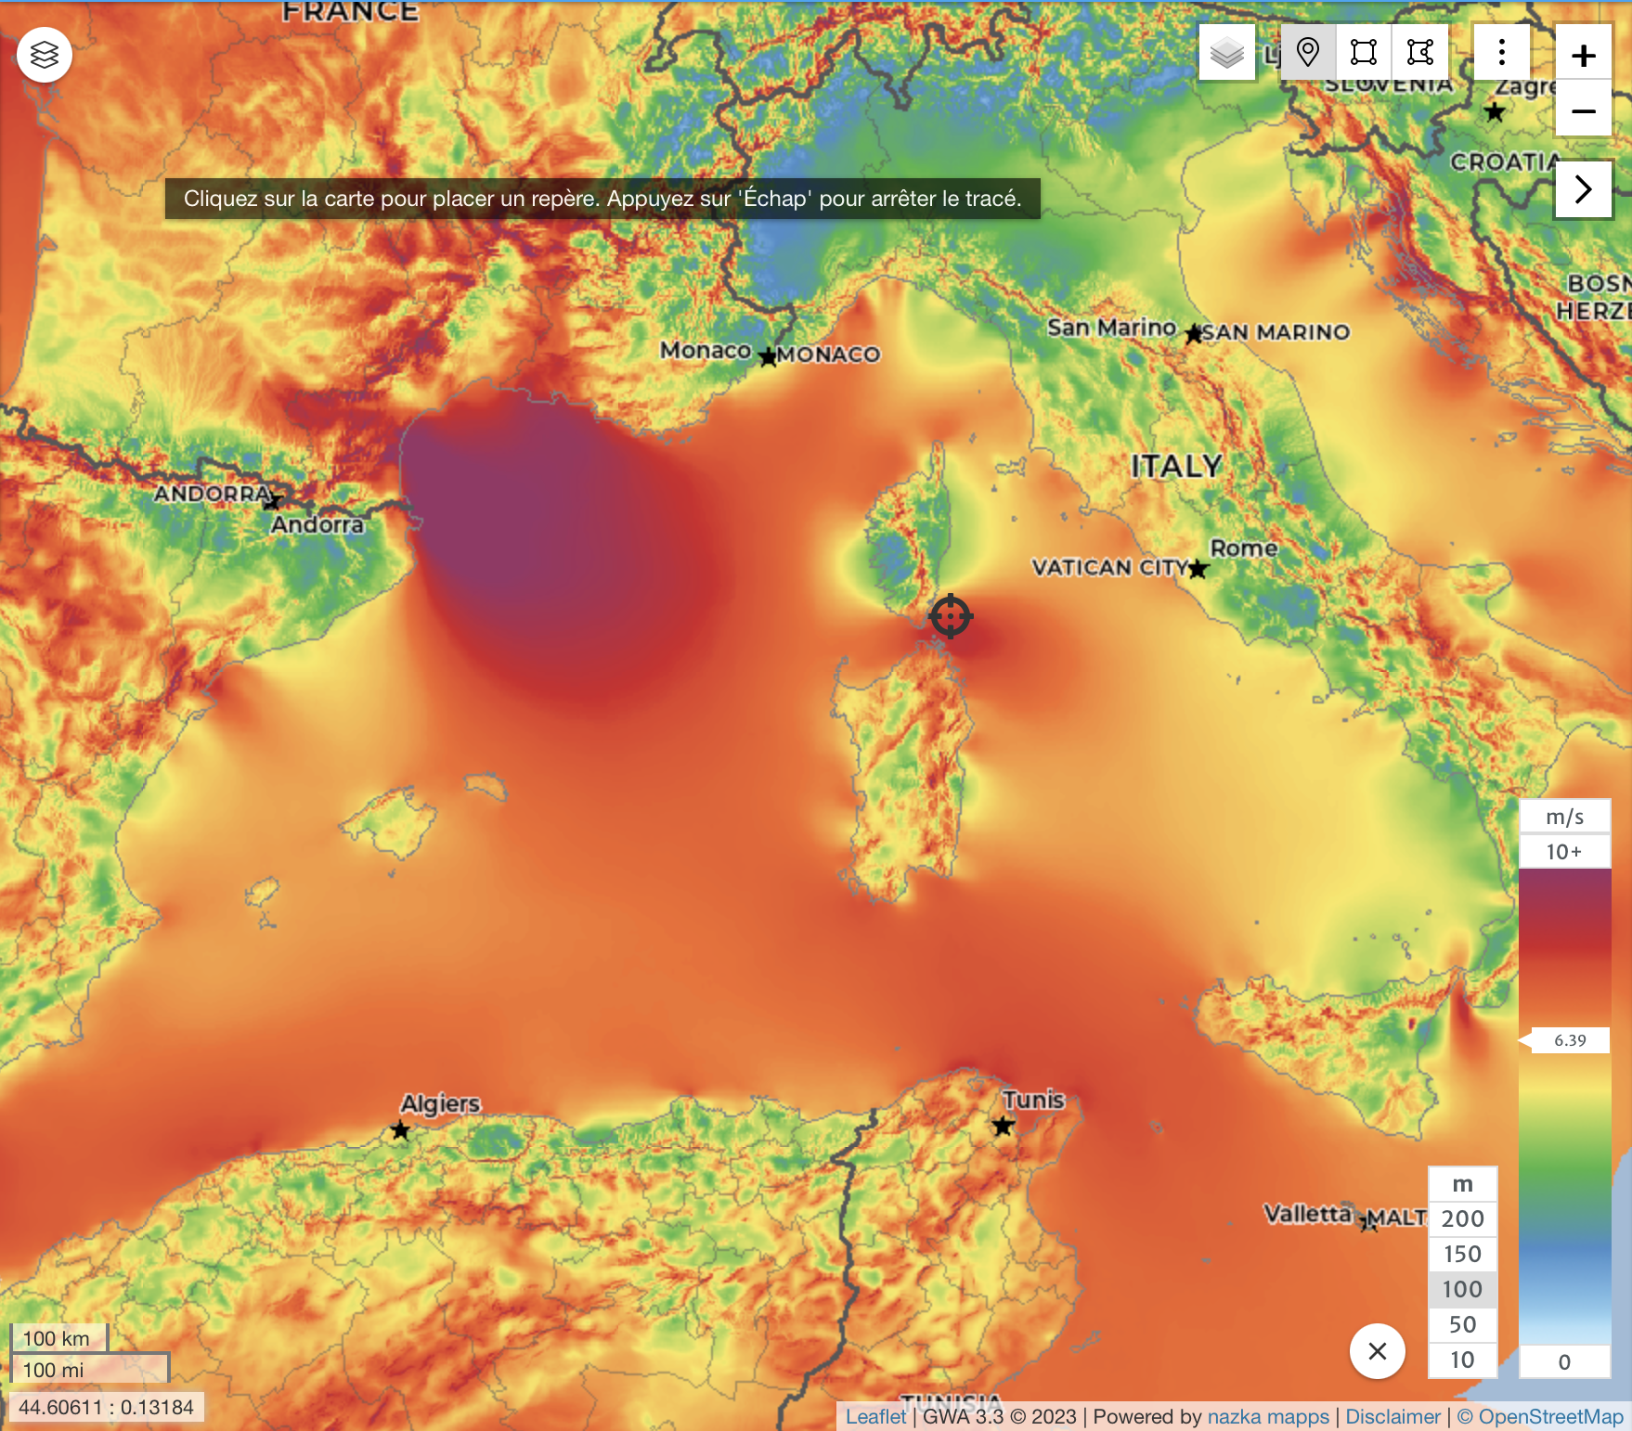

*Figure 1,Our turbine placement Climate<coordinates>41.472831,9.549866,0.0</coordinates>*

Once the placement was chosen, we downloaded the csv data from the global wind atlas website and tabulated the wind speed for the area in a coherent manner.

As expected, our location roughness is close to 0m mainly because it is in open sea where the wind resources are more stable without significant turbulence.   
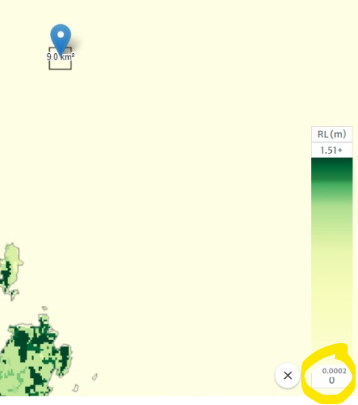

*Figure 2, roughness of our turbine-s location*

After tabulating and formatting all the CSV wind speed data for our turbine location, we focus on the data with the closest roughness to our location (0,0002m)

*Figure 3,tabulated wind speeds, detail for 0m roughness*

### Choosing the Turbine (SG 8.0-167 DD):

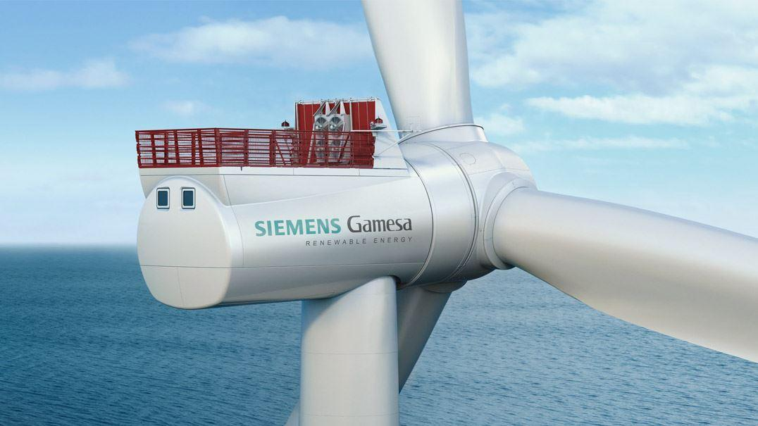

*Figure 4, Siemens Gamesa SG 8.0-167 DD turbine*

For choosing our turbine we considered the following factors:

* The turbine must be built within the EU, offshore, and currently in production.
* Available [turbine characteristics](https://www.thewindpower.net/turbine_fr_1558_siemens-gamesa_sg-8.0-167-dd.php) and Power curves.
* The turbine’s IEC class nominal wind speed rate should match our location's median wind speed. according to the following table

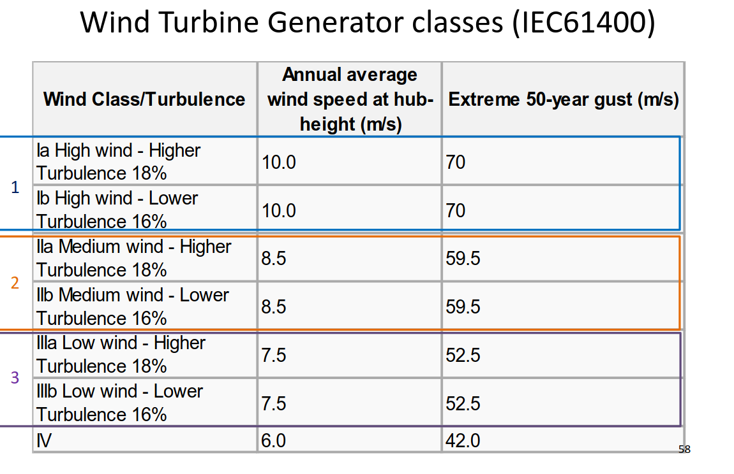

Our turbine has no gearbox (has direct drive), that increases efficiency (specially at low wind speeds) and simplifies the maintenance, but the upfront cost is much higher.

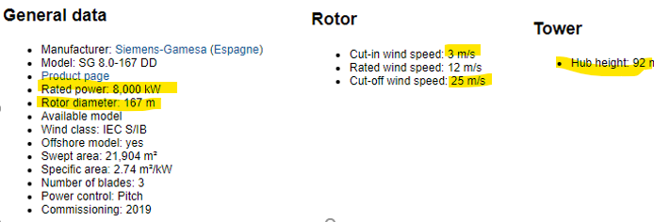

*Figure 5, some of our turbine specs*

## 

## II - Calculate the wind speed distribution:

### Calculation of the Weibull parameters: c and k

The formulas for total c and k for different roughness values are:

$c_{tot } =\frac{\sum_{∀i}{}{ freq}_{i} × c_{i}}{\sum_{∀i}{} {freq}_{i}}$ and ${ k}_{tot} = \frac{\sum_{∀i}{} {freq}_{i} × k_{i}}{\sum_{∀i}{} {freq}_{i}}$

Introducing them in excel for our turbine hub height of 100m and our location wind speed we get the following Weibull’s scale and shape parameters:

|  |  |
| --- | --- |
| c[m/s] | 9,405196965 |
| k | 2,64658192 |

### Calculation of the wind speed frequency in 1m/s intervals:

Using the c and k parameters, we calculated the frequency for each wind speed of 1 m/s bins, using the Weibull formula:

$$F\left(v<V \right)=weibull\left(V,k,c,True\right)$$

$$P(v1≤v≤v2)=\int_{v1}^{v2}{}p(v)dv=F(v2)-F(v1)$$

And then we also calculated the number of hours per year of each wind speed bin: 8760 x P(v1, v2)

*Figure 6, Weibull distribution values*

Plotting the data from Figure 6, gives us Figure 7, our wind speed frequency distribution.  
We will use it to calculate our turbine’s energy production in next chapters.

*Figure 7, Our Weibull distribution*

## III - Calculate the total energy production:

### Power curve:

To calculate how much energy is packed in the air on our turbine location, we need to know the exact air density.

Considering that the air density at a certain height z above sea level can be calculated as: $ρ=\left(\frac{p_{0}}{R.T}\right).e^{\left(\frac{-g.z}{R.T}\right)}$

Where:  
- is the standard sea level pressure = 101325 Pa  
- T is the temperature. T [K] = 288 K – 0.0065 [K/m] * z [m]   
- R is the specific gas constant R = 287.04 J/kg*K  
- g is the gravitational constant. g = 9.81 m/s2  
- z = 92 meters for our chosen turbine hub

We get a $ρ=1,2148$

Luckily for us, our manufacturer provides a power curve, but all values are taken with standard air density of:

$$ρ_{standard}=1,225$$

So, after adjusting for our specific air density (less than standard) with the method suggested by [IEC 61400-12](https://www.emd-international.com/files/windpro/WindPRO_Power_Curve_Options.pdf) (air density correction) we get the following power curve:

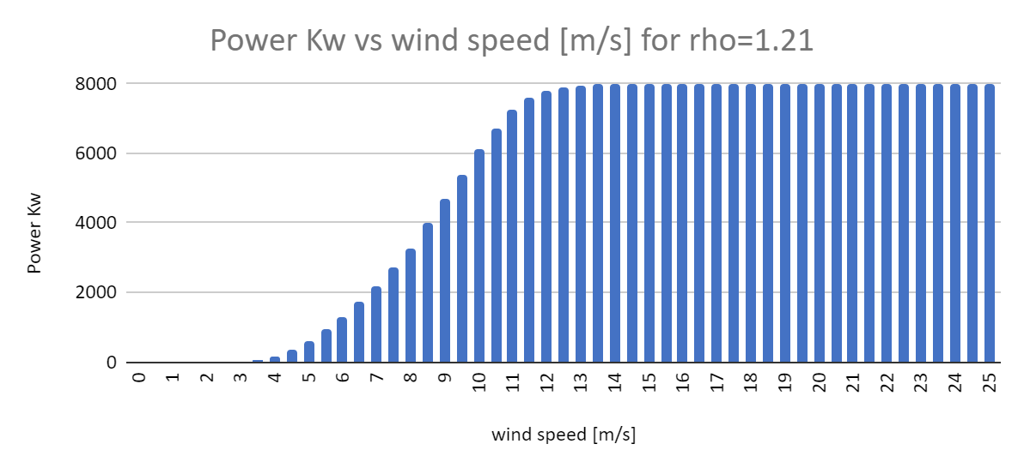

*Figure 8, Corrected Power curve*

With a maximum Power generation of 8000KW

### Capacity factor (CF):

To calculate how close will be our turbine to its full power generation capacity, we first calculate the energy it would produce if working with optimum winds the whole year.

We also adjust that energy calculation with a coeficient of 20% for losses .

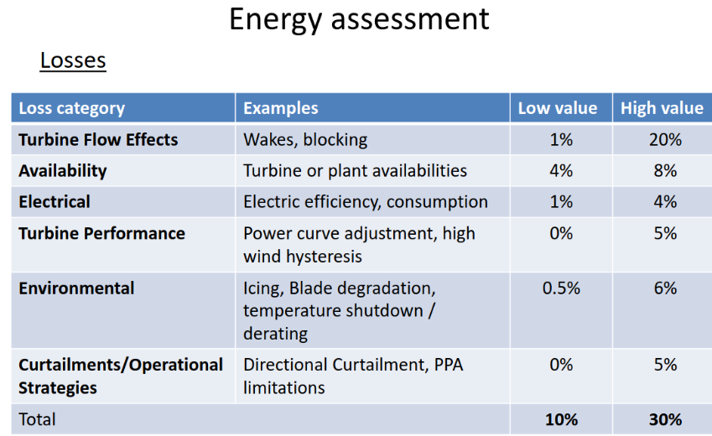

*Figure 9, losses average to 20%*

$$E_{max}=P* t* losses$$

$$E_{max}=8000* 8760*\left(1-0,2\right)$$

$$E_{max}= 56064 MWh$$

Crossing the previously calculated power curve with our Weibull distribution (wind speed frequencies) we end up with a yearly energy production of:

$$E_{N} = 28979 MWh$$

And then we were able to calculate the capacity factor (CF)

$$CF=\frac{E_{N}}{E_{max}}CF=\frac{28979}{56064}CF=51,68\%$$

Which means: our turbine will be generating 51,68% of the power it could be generating in the case of ideal wind conditions for the whole year at our chosen location, that’s a good CF value.

### Power coefficient (CP):

Cp basically is the ratio of actual electric power produced by a wind turbine divided by the total wind power flowing into the turbine blades at specific wind speed.

To calculate the total wind power flowing into the turbine at each wind speed value we used the next formula:

$P_{wind}=\left(\frac{1}{2}\right)*ρ*A*v^{3}$

Then knowing that CP is:

$$Cp=\frac{Pgenerated}{P_{wind}}$$

We get our Cp values for each wind speed, or in other words, how much Power our turbine is extracting from the wind itself.

The Cp curve has the shape expected as for low speeds the Cp gradually increases to reach its optimal value and then on high speeds Cp reduced because of pitch to keep the power extracted at is nominal value

*Figure 10, Power coefficient for each wind speed of our turbine*

## 

## IV - Wind turbine cost analysis:

We will divide this section into three sub-sections, corresponding to two separate calculations, and a final section analysing the influence of these two calculated parameters on the wind turbine.

### Wind turbine cost estimate:

To estimate the cost of the turbine, we used the following formula  
(given for this assignment 1):

$$COST = 7,2 ×P^{0,81}+ 25102×D^{0,92}$$

P: Wind Turbine Power.

D: Rotor Diameter.

For our specific turbine (figure 5) those values are:

$P = 8 000 000 W$

$D = 167 m$

We have therefore also performed this calculation in Excel: 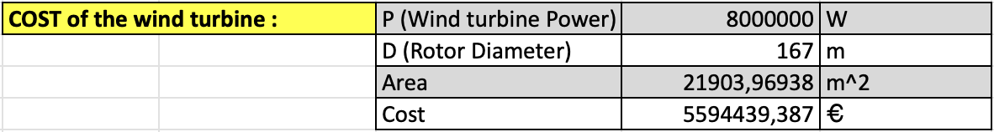

*Figure SEQ Figure \* ARABIC 11,Cost estimation of our turbine*

So, thanks to the calculations and the formula presented, we have obtained the following cost value:

$$COST = 5 594 439,39 €$$

### Calculation of LCOE (without financing):

The LCOE means “levelized cost of electricity”, it’s an economic measure used to compare lifetime costs of generating electricity between different turbines.

To calculate the LCOE parameter, we used the following simple formula:

$$LCOE = \frac{\frac{CAPEX}{N} + OPEX}{AEP}$$

So, we have these four parameters in the in the previous formula:

CAPEX: Capital Expenditure [€]

OPEX: External Operations

AEP: Annual Energy Production

N: Lifetime

So, we have therefore also performed this calculation in Excel:

|  |  |  |
| --- | --- | --- |
| Calculation of LCOE |  |  |
| Pnom | 8 | MW |
| Cfactor | 0,416965424 | %uno |
| AEP | 29220,93691 | Mwh |
| CAPEX | 5,44 | Million € |
| OPEX | 0,23 | Million € |
| Lifetime | 22 | years |
| LCOE | 16,33324519 | €/Mwh |
|  |  |  |
| hours/day | 24 |  |
| days/year | 365 |  |
| hours/year | 8760 |  |

*Figure 12, levelized cost of electricity (LCOE) of our turbine*

Finally, we have obtained the following LCOE and we can show it to our investors:

$$LCOE = 16,33 €/MWh$$

It takes 16,33€ in costs for our turbine to produce each MW/h (no financing costs)

### 

### Calculation of LCOE (with financing):

We don’t have 5,5 million € laying around so we probably need to take a loan.

It seems like a usual interest rate for long term (22yrs) loans in Spain is 3.71% (figure 12), we are going to take this interest into account in our LCOE calculations:

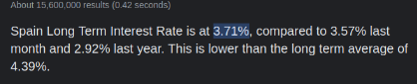

*Figure 13, google search for interest for loans in spain*

Our LCOE ecuation including financing costs turns out to be:

$$LCOE = \frac{\frac{CAPEX+FIN}{N} + OPEX}{AEP}$$

Where:

CAPEX: Capital Expenditure [€]

OPEX: External Operations

AEP: Annual Energy Production

N: Lifetime

FIN: financing costs

It looks like our LCOE with financing costs raised roughly 24% up to:

$LCOE = 20,40 €/MWh$

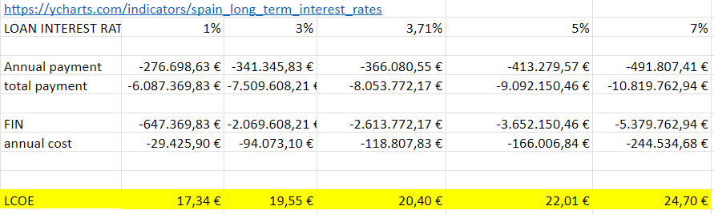

*Figure 14, Our LCOE calculation for different interest rates*

## 

## V - Economic income calculation

First, we search for the most recent Energy prices in spain (per Mwh)

|  |  |  |  |
| --- | --- | --- | --- |
| Mes | min price | Avg price | Max price |
| Ene | 0 | 69,55 | 220 |
| Feb | 4,16 | 133,47 | 189,74 |
| Mar | 0 | 89,61 | 190 |
| Abr | 0 | 73,73 | 166,06 |
| May | 0 | 74,21 | 148,16 |
| Jun | 0 | 93,02 | 156,13 |
| Jul | 0 | 90,47 | 151,65 |
| Ago | 0 | 96,05 | 180,34 |
| Sep | 0 | 103,34 | 170 |
|  | Averaged Price for the year (until September) | 91,49444444 | €/Mwh |

It turns out the Megawatt/h is being paid at 91,5€

$$avg price per MWh = 91.494€$$

Now calculating our benefit per MWh with different LCOE’s and the price of MWh in the Spanish market:

|  |  |  |  |  |  |
| --- | --- | --- | --- | --- | --- |
| LOAN INTEREST RATE | 1% | 3% | **3,71%** | 5% | 7% |
| PROFIT PER MW | 74,15 € | 71,94 € | **71,10 €** | 69,48 € | 66,79 € |

We finally have a magic number to show to our investors:

$$Benefit per MWh = 71.10€$$

Which taking into account our turbine energy production of 29000 MW/year:

$$Benefit per year≈ 2.000.000€$$

Knowing the benefit per MWh also allows us to plot the next graph:

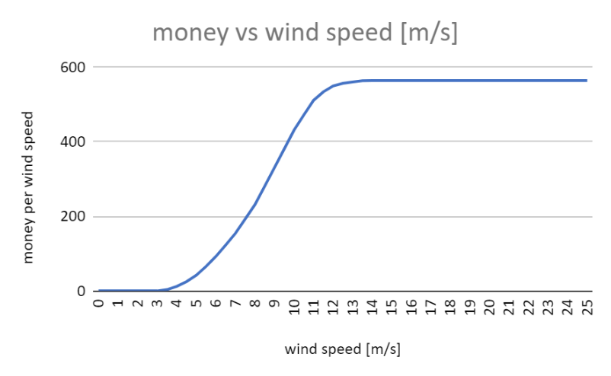

*Figure 15, benefit in € per wind speed*

## 

## VI - Openwind validation

### Open wind values

For this last part of the assignment the objective is to validate the results we get from Peralta plant, adjusted to the masts through OpenQind.

In general the process we followed during the lab of the OpenWind can be summarised as follows:

* First we chose the appropriate map projection as well as the UTM WGS84 zone **21S** which corresponds to the location of the wind park
* Then we imported the raw workbook which contains the raw values of the wind resources of the area (+some more settings which in the case of the report we are going to avoid).  
  These raw data have a high resolution as they are produced by the combination of 2 different process (meso-scale and micro-scale simulations & Weather Forecast Model WRF)
* The next part was about importing the met mast data. By doing this, it was possible to readjust the map the OpenWind tools in order to obtain more accurate wind speed values
* Then for the last part we
  + Chose our wind turbine (“Vestas_V110- 2.0MW_100mHH”)
  + Imported the already given Site layout
  + Defined which turbines are associated with which met masts
  + Ran an energy capture

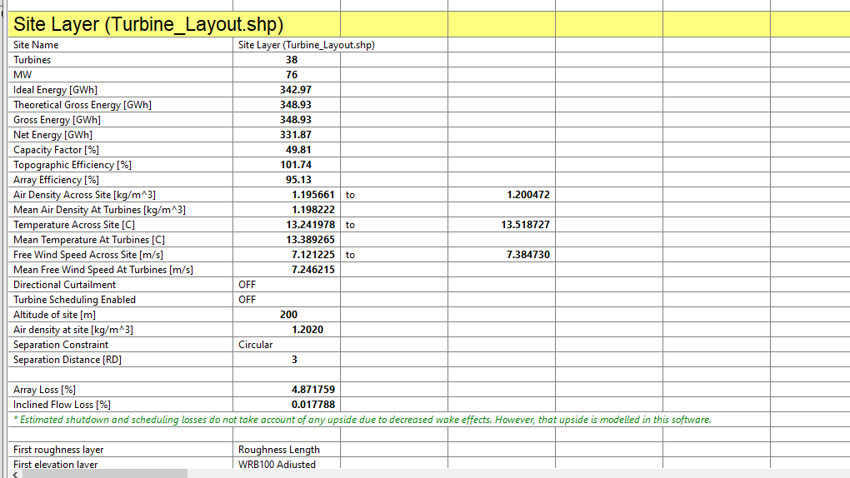

*Figure 16, OpenWind Results*

Although the results are slightly different from the ones shown in the tutorial we are confident that this might have occurred due to other teaming of the turbines. Our results considering the Gross production as well as 3 losses scenarios are the following:

|  |  |
| --- | --- |
| **Ideal Energy (GWh)** | 342,97 |
| **Theoretical Gross Energy (GWh)** | 348,93 |
| **Gross Energy(GWh)** | 348,93 |
| **Net Energy(GWh)** | 331,87 |
| **Losses** | **Net Production (GWh)** |
| 10% | 314,037 |
| 15% | 296,5905 |
| 20% | 279,144 |

### Excel data produced for Peralta site

For this part we followed almost the same steps as described in the previous sections of this report. The process is summarised in the following steps:

1. We downloaded the GWC for the location given (lat: -32.6111°, lon: -56.4166°)
2. We measured the roughness length as 0.03 m  
   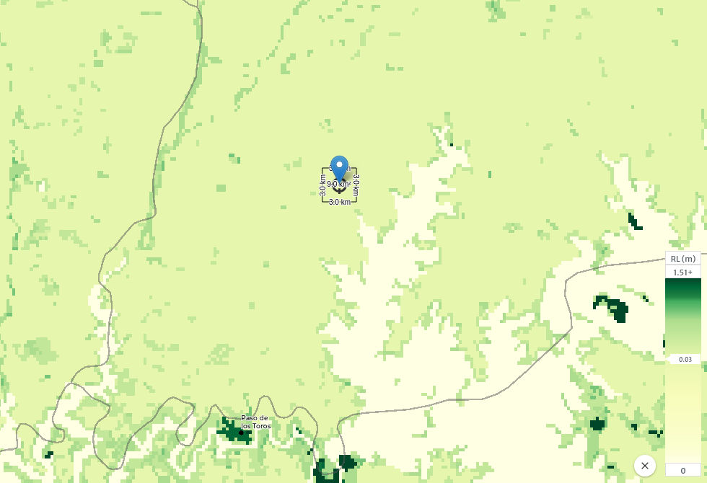

|  |  |
| --- | --- |
| c[m/s] | 8,49241858 |
| k | 2,709321603 |

1. We calculated the **c** and **k** parameters considering hub height to be 200m as in the OpenWind simulation

|  |  |
| --- | --- |
| **Peralta Results from GlobalWindAtlas** | |
| **Losses** | **Net Production (GWh)** |
| 10% | 333,43 |
| 15% | 314,91 |
| 20% | 296,39 |
| CF (%) | 55,64 |

1. Then we calculated the wind speed frequency in 1 m/s intervals and extracted the associated Weibull like figure.  
   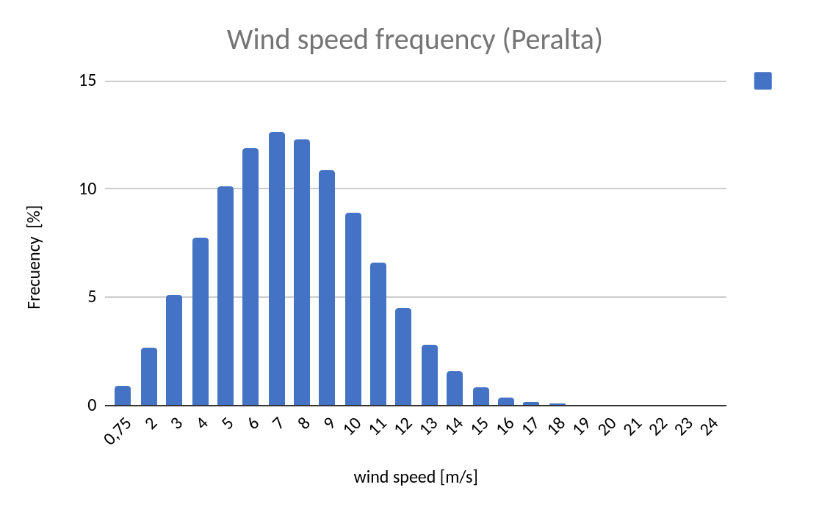
2. For the air density rho=1.2 kg/m3 given in the OpenWind we chose the corresponding Power Curve. And then finally we multiplied the results of the turbine by 38 to get the same magnitude of values as in OpenWind.  
   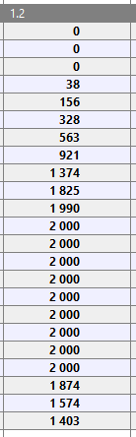

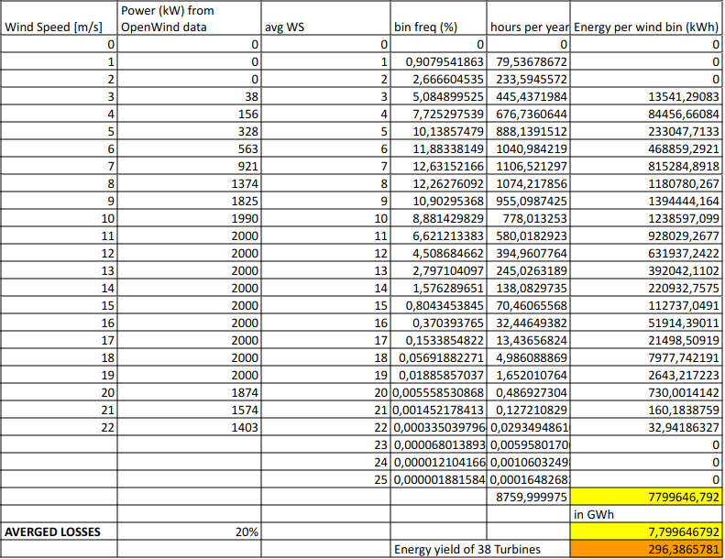

### Comparison

So after describing the two processes followed to get our results (OpenWind from one side and GlobalWindAtlas+Excel from the other) we can now represent the values obtained.

|  |  |  |
| --- | --- | --- |
|  | **OpenWind** | **GlobalWindAtlas** |
| **Losses** | **Net Production (GWh)** | |
| 10% | 314,04 | 333,43 |
| 15% | 296,59 | 314,91 |
| 20% | 279,14 | 296,39 |
| CF (%)  (0 losses) | 49,81 | 55,65 |
| 10% | 47,17 | 50,08 |
| 15% | 44,55 | 47,30 |
| 20% | 41,93 | 44,52 |

In general all values obtained from the GlobalWindAtlas data seem to be a bit greater than the results obtained from the OpenWind data.

The different values shown in the above array between the two methods could be the result of the following:

* Turbulence considered in OpenWind
* Small changes in air density in Open Wind
* All turbines in the GWA method considered to be in the same above-sea height
* Wake effects considered in OpenWind while not in the GWA method

### 